|  |  |
| --- | --- |
| Roll No.: A016 | Name: Varun Khadayate |
| Class: B. Tech CsBs | Batch: 1 |
| Date of Experiment: 25-09-2022 | Subject: ITWS |

Lab 10: M Script Debugging

# Code with error

function [vals, locs]=local_max(v)

n=length(v);

vals=[];

locs=[];

for m=1:n

if v(m)-v(m-1)>0 && v(m)-v(m+1)>0

vals = [vals;v(m)];

locs = [locs;m];

end

end

figure; plot(v);

hold on;

plot(locs,vals,'ro');

# Running the file in the command window at first

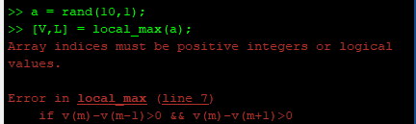

Error is received so will use step debugging

# Setting Step debug in line 2 from where the file is running



# Running the step debug in command window

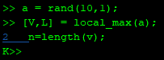

# Click on the step button to go to next step



# You will find there is an error in line 7 as its shown in command window

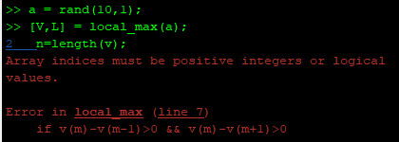

# Changing value from for **m=1:n** to **m=2:n**

# Once again setting the breakpoint in line 2 and running it



# After doing it continue the above step by clicking on step button again and again till the graph is received like this

